How has the growth of broadband access and digital information affected the diffusion of public policies across the US states over time? Over the past two decades broadband, or high-speed internet, has fundamentally transformed how information is consumed and spreads. The changes are comparable to the invention of the printing press, telegram, and telephone (Chadwick 2017; Silver 2015; Shirky 2008). Each of these new technologies transformed society and structurally altered how information flows. Former OECD chief economist Ignazio Visco has argued that because of broadband “The dramatic fall in communication costs […] and the technological breakthroughs behind it, have led to a diffusion of ideas, technological know-how and a general spread of information at a pace that is quite unprecedented in the history of humankind” (Clark and Thompson, 2012).
This study examines how variation in household broadband subscription rates has influenced the spread of policy adoptions across U.S. states. Information plays a central role in the diffusion of policy solutions, and states with higher rates of broadband subscriptions operate in a more information rich, nationalized environment. Measuring broadband subscriptions, or the percent of the population with high speed internet access, provides an indicator of how widespread and inclusive information networks are within states, potentially enriching the flows of information. Despite the critical significance of the internet for information and communication, the role of broadband access and use has not previously been considered in a systematic way to explain the diffusion of policies across the states.
Some diffusion scholars have documented that states have become more innovative over time (Boehmke and Skinner 2012), with others offering digital information and communication technologies as an explanation for this trend because they increase the speed at which information travels (Boushey 2010, 23). We argue that the growth of broadband access and use may help explain differences in state innovation as well as other changes such as the decline in the importance of geography in the spread of new policy ideas. The internet may not only increase the speed at which ideas circulate but change the flow of information by creating more nationalized information environments.
To our knowledge, this study is the first to examine the influence of broadband connectivity in state policy diffusion. We model thousands of adoptions of state policies over the past four decades through a pooled event history analysis (Kreitzer and Boehmke 2016) using the State Policy Innovation and Diffusion Database (SPID) (Boehmke et al 2020). The results suggest digital information access is associated with significantly higher rates of policy innovation. These results hold in an instrumental variable analysis that strips out factors that may predict both innovation and broadband.
We also find that widespread internet use has significantly reduced the influence of geographic proximity on policy adoption. While geographic contiguity, or neighboring states, still positively predicts state policy adoption, high rates of broadband use reduce its importance. Taken together, our findings suggest that broadband connectivity has created a more information rich, nationalized environment where policies spread more quickly and are less dependent on geography to spread.
Growing Innovation and Nationalization of the Diffusion Network
Political scientists have long studied what causes some policies to diffuse widely and others to not, with a focus on the comparative advantage of studying the fifty U.S. states (Walker 1969; Gray 1973). Berry and Berry’s (1990) introduction of event history analysis opened a new wave of interest in policy diffusion as scholars could use internal (i.e. legislative professionalism, population, state ideology) and external (i.e. neighboring state adoptions, latent diffusion ties) characteristics of states to model policy diffusion across geography. This methodological change led to a large growth in single policy studies that provided important insights to the predictors of policy diffusion (Grossback, Nicholson-Crotty and Peterson 2004; Boushey 2010).
Recently, there has been a shift toward studies that take a large-N approach to measuring policy diffusion, often using dozens or hundreds of policies to systematically identify spatial patterns of policy diffusion (Boehmke and Skinner 2012; Boehmke et al 2020; Boushey 2010; Bricker and LaCombe 2020; Karch, Nicholson-Crotty, and Bowman 2016; Mallinson 2019). This trend has enabled researchers to identify consistent and more generalizable diffusion patterns across multiple policy areas. The SPID dataset (Boehmke et al 2020) is the most comprehensive to date, with data on thousands of policies across all topic areas, ranging from gun control measures, to abortion restrictions, to regulatory policies from the Uniform Law Commission.
Despite the variety in methodological and theoretical approaches to understanding how policies spread, a central component is typically the role of information exchanges in policy diffusion (Boushey 2010; Nicholson-Crotty and Carley 2018), although this is typically not measured directly but rather through the ways that information flows, be it due to geographic proximity, a contagion effect, or latent diffusion ties. Whether competing, learning, or imitating (Shipan and Volden 2008), states use information about what other states are doing when they innovate, or adopt new policies. Information plays a vital role in the spread of ideas and states’ ability to find policy prescriptions for emerging problems (Hale 2011). Information is not just constrained to adopting policies with successful outcomes such as higher economic growth or increased approval from voters. For example, previous adopters send information to other states about the ideological location of a policy (Grossback, Nicholson-Crotty & Peterson 2004) so lawmakers can quickly learn if a new policy is politically viable (Butler et al 2017).
We focus on two recent dynamics that have been observed by those who study state policy diffusion. First, states have become more innovative over time (Boehmke and Skinner 2012: Boehmke et al 2020). Whether using Walker’s (1969) original innovativeness score or the more recent “rate score” (Boehmke and Skinner 2012), states have experienced a rapid growth in innovativeness beginning in the 1990s. The cause of recent spikes in the number of policy adoptions is less clear. We argue that broadband has contributed to this dynamic by increasing the availability of information to policymakers to learn about policies adopted across states and local communities.
Second, scholars have found that states are more likely to adopt policies when neighboring states have already done so (Walker 1969, Gray 1973; Berry and Baybeck 2005). Geographic proximity means states can easily observe what policies neighboring states are adopting, and citizens near state borders are likely exposed to neighboring state policy changes (Pacheco 2012). Walker (1969) argued that contiguity played an important role in diffusion because it facilitates information flows for elites to learn about new ideas and receive other relevant cues about whether they should adopt a policy. Geographic proximity suggests that the cost of getting information about neighboring state policies is lower than learning about state policies hundreds or thousands of miles away.
Digital Information Access & State Information Networks
Digital information now drives participation in politics, jobs and commercial activity ( DiMaggio and Bonikowski 2008), economic growth, and societal change, yet internet access (both at the micro and macro level) is unequal (Tomer, Kneebone and Shivaram 2017; Mossberger et al 2003, 2012; Norris 2001; Schlozman et al 2010). This is patterned by race, ethnicity, education, income and age, and unevenly distributed across communities and states (Mossberger, Tolbert and LaCombe 2021). There is considerable variation in broadband subscription rates across states. In 2014, for example, there was a 23% gap between the state with the highest (New Hampshire at 86%) and lowest (Mississippi 63%) household broadband subscription rate. From 2005 to 2009, when broadband subscriptions were rapidly increasing across the county, this gap between the most and least connected states grew to as large as 35%. On average, states in the South tend to have the lowest subscription rates, while those in the North East and West Coast have the highest. How might we expect this to affect information networks within states and across state lines? Why is it that broadband subscriptions in the population (not just in the halls of the state capitol) might change how policies diffuse?
Broadband impacts what policy scholars have called the public, systemic or government agenda (Kingdon 1995; Cobb and Elder 1972) through the availability of information and opportunities to communicate ideas and preferences with other citizens and/or policymakers such as legislators or administrators. Such public agendas have traditionally been measured by issue attention in the media (Baumgartner and Jones 1993; Jones and Baumgartner 2005; Downs 1972; Kingdon 1995; Zahariadas 2016). While local television and newspaper coverage highlight local candidates and issues (Prior 2006; Snyder and Stromberg 2008), digital media has shifted information flows to national sources that cover the entire country rather than focus on local topics (Lelkes et al 2015; Hindman 2008).
Broadband and digital media have changed the information environment in other ways as well, diversifying sources beyond traditional media and incorporating new forms of civic engagement (Feezell 2017). Broadband provides new platforms such as social media for public discussion and displays of public opinion that policymakers can view (Gainous and Wagner 2013), and that are in turn often amplified by the traditional press in a hybrid media environment (Chadwick 2017). In this environment, more issues may have a chance to emerge on the public agenda and possibly legislative agendas. The costs of media diversification and fragmentation has been debated (Sunstein 2007), but one impact may be the introduction of more ideas and issues in the public sphere, and more nationalized public agenda.
Ideas considered by policymakers may come from a variety of sources – from interest groups, media, think tanks, professional networks and informal contacts with other states (Kingdon 1995; Mossberger 2000; Balla 2001; Boushey 2010; Garret and Jansa 2015). High-speed internet has meant that over time state policymakers can easily access a variety of sources and ideas, such as looking up model legislation from the National Conference of State Legislatures (NCSL) or advocacy groups (see West 2004 on e-government). More policy alternatives can be accessed more quickly, with more detailed information than in the past.
A significant body of research finds a positive effect of contiguity on policy adoption (Walker 1969; Berry and Bayback 2005; see Gilardi 2016 and Magetti and Gilardi’s 2016 for detailed overviews of how geographic proximity has been used in diffusion research). In the most comprehensive meta-analysis review to date of diffusion studies, Mallinson (WP, APSA Pre-print) finds that neighbors/geographic contiguity remains one of the most common covariates in models of state policy diffusion (73% of the 507 studies analyzed), along with measures of slack resources, ideology, and legislative professionalism. Mallinson notes this is one of the few variables in his literature review that has a consistently positive effect on policy innovation across hundreds of publications, albeit with heterogeneous effects depending on the issue area. His final conclusion is that “there is evidence of general effects across the existing studies for the positive effects of neighbor adoptions…” (26, Forthcoming). Geographic continuity is thus a primary explanation for why states adopt new policies.
Today there is an ongoing discussion in the literature both re-evaluating the role of traditional diffusion predictors as well as explaining the variation in their effects over time. While Mooney (2001) argues that the field has not sufficiently tested the implicit theoretical underpinnings of geographic proximity driving learning, others have countered that it may only apply to certain policies or may mask other underlying processes. For example, there should be heterogeneity in contiguity’s effect on policy diffusion because government leaders may learn that a policy causes harm (however defined) so neighboring states should be less likely to adopt a failed policy (Dolowitz and Marsh 1996). Mooney (2001) also posits that in more nationalized information environments, shared state borders should play a smaller role.
Scholars have increasingly identified alternative pathways for state policies to diffuse. Desmarais et al (2015), for example, leveraged over time policy adoptions across hundreds of policy areas and thousands of unique state policy adoptions to identify “latent diffusion ties,” or pathways new policies persistently take; in so doing the research identifies a state policy network with some states as sources for future policy adoptions. Other scholars have leveraged unique public opinion data over time to identify which states are perceived as similar to each other; the result show that citizen perceptions play a much stronger role than geographic proximity in state policy diffusion over time (Bricker and LaCombe 2020).
Mallinson (2019) found that geographic contiguity’s influence has waned in the last few decades. Boushey (2010, 60-61) suggests that changes in information and communications technologies may have sped up these diffusion processes, but he doesn’t directly test this. While we cannot directly test the processes by which broadband increases the flow of policy ideas, prior research identifies many ways technology increases the volume, speed and reach of information. Over time, with advances in digital technologies and applications, we expect that that this may expand state information networks for both the public and government officials.
Research Hypotheses: Digital Information & State Policy Adoptions
Rising from less than 5% of the population with a home broadband connection in 2000 to 85% in 2018 (combining wired or satellite home broadband 65% and cell phone only 20%, American Community Survey 2019), the past two decades have seen a dramatic transformation of digital information access. The growth of broadband connectivity has been primarily due to private investment and infrastructure, not federal or state policy. Widespread internet use has made the flow of information much easier and faster than in the past, increasing the ease of connecting not only policymakers, but advocates and citizens (see Boushey 2010). For example, the Uniform Law Commission provides over 150 sample policies for states to use, as well as resources for states to learn about what other states and the federal government are adopting on the same topic. While 50 years ago the organization would have to send representatives to state legislatures to advocate for policies, they can now hold nationwide virtual conferences and provide instant updates about new policies and adoptions. Websites for the NCSL, think-tanks, non-profits, departments of commerce, industry organizations and more provide legislative search engines across extensive policy areas. Not only do existing interest groups have lower organizational costs, but the growth of the internet has democratized the process of organizing interests, which facilitated a massive growth in self-organizing groups that can advocate without being dependent on traditional organized interests (Shirky 2008). The internet has changed how information spreads from state to state by increasing the amount of information available, and greatly reducing the cost of finding new information.
This leads us to two predictions. First, as broadband subscription rates become more prevalent in a state, states receive substantially more information from citizens, interest groups, and other states. There is a greater diversity of ideas and sources of information, as well as rapid knowledge of developments elsewhere. This should result in states being more innovative.
Hypothesis 1: States with higher broadband subscription rates are more likely to adopt a policy on average.
At the same time, broadband is expected to alter existing networks of information flows, by enabling people to easily communicate across geographies. As the cost to learn about what far away states are doing to tackle policy problems goes down, the role of geographic proximity should decrease. Citizens and elites can also be exposed to different policy changes through exposure on social media or other platforms and are more aware of what states across the country are doing than ever before (Hopkins 2018). This nationalized information environment should affect both voter and elite considerations away from local considerations and toward national issues (Trussler 2019), which is expected to reduce the role of neighboring state adoptions (Mooney 2001; Mallinson 2019). The growth of broadband has not only nationalized the information environment but made it easier for interests to disseminate information across large distances, and dramatically reduced the costs of forming advocacy groups on a national scale.
Hypothesis 2: Higher broadband subscription rates should reduce the effect of geographic proximity on state policy innovation over time.
Research Design
While single policy analyses play an important role in identifying diffusion processes and mechanisms, they come at the cost of potentially being a function of the specific policy being tested, which may lead to idiosyncratic findings. Seeking more generalizable results, our study uses a much larger dataset of state policy adoptions to test how broadband systematically affects the diffusion of policies across issue areas. To test our hypotheses, we use the State Policy Innovation and Diffusion Dataset (SPID) (Boehmke et al 2020). These data include information on thousands of policy adoptions on hundreds of policies in all 50 states across a variety of policy areas from the 1800s through 2016. When merged with broadband subscription data, we examine over 1,600 adoptions of 105 policies, and over 26,000 total policy-state-year observations from 2000 to 2016. This larger dataset of policies provides more confidence that the findings are not a due to outlier policy issues, but rather reflect the broader diffusion environment. The dependent variable is a binary measure of whether a state adopted a policy in a given year.
Our key independent variable is a measure of broadband subscription rates in the states from 2000-2016 from the American Community Survey and Current Population Survey (including this both mobile and fixed high-speed internet connections). A broadband connection is defined as “having at least one type of internet subscription other than a dial-up subscription alone” (Ryan 2018). Figure 1 shows the distribution of broadband subscription rates in the states over time. In the first time point, 2000, no state has more than 10% broadband usage rates. Subscription rates quickly rise to between 25-50% of the population having broadband subscriptions in 2005, and then to every state having over 60% subscriptions by 2015. While access to the internet has rapidly spread across the entire country, there are still large differences between the states, with gaps up to 25% between the states with the highest and lowest rates of broadband subscription.
An event history analysis (EHA) is used to estimate the probability of a state adopting a policy over time, which allows us to model both the external and internal determinants of policy adoption (Berry and Berry 1990). A state becomes at risk of adopting a policy after any state adopts a given policy. So, if California adopts a policy, such as the coronavirus “stay-at-home order/self-quarantine,” the other 49 states become at risk of adopting that policy each year until they adopt the policy. Once a state adopts a policy it drops out of the risk set as it is no longer at risk of adopting the policy. Each policy has its own risk set, and an event history analysis models the probability of a state adopting a policy in a given year. We use an alteration of the EHA called the pooled event history analysis (PEHA) that follows Kreizter and Boehmke’s approach to pooling risk sets by including random intercepts for each policy (2016); this method allows for pooling findings into a single, unified model while also recognizing that each policy as a distinct baseline probability of adoption.
The key independent variable is a measure of the proportion of households that have broadband subscriptions in a state. The first model includes this variable in a typical model of state policy diffusion, with internal controls for legislative professionalism (Squire 2007), median income per capita, state population, percent Black in the population, a measure of unified party control, and public opinion ideological liberalism using Caughey and Warshaw’s (2018) measure of mass public liberalism generated from a hundreds of public opinion surveys. Year fixed effects are used to account for year specific effects and a cubic polynomial for duration accounts for the time a state has been at risk of adopting a policy. Ideological polarization could lead states to take up new policies more quickly and be less reliant on geographic neighbors. To address this concern, we include a measure for the sum of the ideological distance (using Caughey and Warshaw’s (2018) measure of policy liberalism) between a state and previously adopting states to control for the influence of ideological proximity; larger values represent larger ideological differences.
We include two measures for external influences on adoption, the first being a lagged count of neighboring states that previously adopted a policy. The second is Desmarais et al’s (2015) measure of decayed latent diffusion ties, which is an inferred network using previous policy adoptions to identify pathways in which policies persistently flow as they diffuse through the states. This is a powerful predictor of policy adoption that measures what states are frequently looked at for policy ideas. Once the pathways have been established states continue to look to these source states for future policy solutions.
Results
The logistic regression coefficients in table 1 (model 1) show how broadband subscription rates are associated with policy adoption from 2000-2016. The results show that both share borders/geographic continuity and latent diffusion ties positively predict policy innovation over time, consistent with much of the previous literature. States are more likely to adopt a policy as the number of contiguous state adoptions increase, and as more states with latent ties adopt that policy. The only statistically significant controls are income per capita and legislative professionalism. The key independent variable, digital information access as proxied by broadband subscription, also is associated with a higher probability of a state adopting a policy. These results support our first hypothesis that broadband access and use increases innovativeness across the state over time.
As a comparison, model 2 (table 1) replicates the analysis for the earlier time period (1980-1999) as a control condition omitting broadband. It shows the counter-factual condition before the introduction of high-speed internet access. Without including a measure of digital information access the effect size for latent network ties and geographic continuity (neighboring states) are similar. Model 3 pools data for the complete time period (1980-2016) with broadband subscriptions set to zero before 2000. Broadband subscriptions remain a powerful predictor of policy adoptions, controlling for standard predictors of policy diffusion, including geographic continuity, latent ties, population size, liberal public opinion and more educated populations. The effect size remains large.
Figure 2 shows the predicted probability of a state adopting a new policy in any given year at different rates of broadband subscriptions using the results from model 1. As the percentage of the population with broadband increases (across states and over time), so does the probability of a state innovating. The effect is substantively very large. The probability of innovation more than doubles from less than a 5% probability of adoption to over a 10% probability as a state’s population goes from low to high levels of broadband subscriptions. A roughly 10% increase in broadband subscription results in a 1% increase the probability of adoption. An increase of 1% is substantively very large when considering that the baseline probability of adopting a policy in any given year is just under 5%, particularly considering when the increase compounds each year. So, a 10% increase in broadband subscription rates increases the baseline probability of adoption by roughly 20%, and these positive effects compound over time. Our next set of models is the same specification, but with an interaction between broadband and previous contiguous state adoptions. This interaction allows a test if increased broadband subscriptions moderates the effect of contiguity on policy innovation.
The results in table 2 include the interaction between geographic contiguity and broadband subscriptions to test hypothesis two. As in the previous table, both base terms for broadband subscription rates and contiguous adoptions predict policy innovation. However, the interaction between the two is negative and statistically significant across the three model specifications—1) 2000-2016 time period (model 1), 2) pooled time period (model 2) and 3) pooled time period with additional binary variable for years before 2000 as an additional robustness check to isolate variation between the two eras (model 3). The negatively signed interaction indicates that higher broadband subscription rates decrease the association between geographic continuity and the probability of a state adopting a new policy.
Figure 3 shows the average marginal effect of geographic contiguity by broadband subscription rates on state policy adoptions (model 1, table 2). The effect of contiguity is positive and statistically significant, as expected. Contiguous state adoptions increase the probability of adoption by roughly three-fourths of a percentage point with each additional contiguous adoption. However, the marginal effect of contiguity decreases as broadband subscription rates surpass 60% of the population. Contiguity no longer positively predicts policy adoption when subscription rates are over 85%. These results support our second hypothesis that broadband has altered flows of information and reduced the role of geography in policy diffusion. States with high levels of digital information are less reliant on contiguous state adoptions for policy solution compared to states with low levels of broadband.
Instrumental Variable Regression (Two-Stage Causal Models)
Lastly, we estimate an instrumental variable model as a robustness check to demonstrate the relationship between the growth of digital information and the spread of diffusion of new policies is not spurious. This is necessary to address concerns about causality and endogeneity, and to strip out of the predictor variable, broadband subscriptions, any factors that might be unmeasured in our models. A two-stage probit uses three geographic variables (state geographic area, average elevation in a state, and Dobson and Campbell’s (2014) measure of the percentage of a state’s area that is flat) to predict rates of broadband subscriptions. These three geographic variables are predicted to predict broadband subscription rates but not policy innovation for multiple reasons (see supplemental material for a more detailed discussion of the instrumental approach and diagnostics used to test the instrument).
Simply put, people can only subscribe to broadband internet if the infrastructure exists (i.e. broadband deployment). Without access to broadband cables, fiber or wireless signals, people cannot sign up for a connection. Broadband lines are expensive to install, and largely privately funded. In larger states internet providers will have to devote more resources to cover geographically larger states. Additionally, rugged terrain such as mountains increases the cost of installing lines for internet access, so providers face more difficulties in installing broadband infrastructure. When geographic barriers to building broadband infrastructure are low, we expect broadband subscription rates to be higher. The second stage of the model includes the same variables we use in the other pooled event history analyses, including contiguous adoptions, latent ties adoptions, policy liberalism, unified government control, state income per capita, legislative professionalism, and the percentage of the population with a high school degree. We also include a cubic polynomial for duration (years until a state adopts a policy), and fixed effects for state and year.
Table 3 shows the results for the two-staged probit model that treats broadband subscription rates as an endogenous predictor of policy adoption. In the first stage of the model, larger states have lower levels of broadband subscription rates, and flatter states on average have higher rates of broadband subscription. States with an average higher elevation have somewhat higher rates of broadband subscription, although the difference is not substantively large. The other demographic variables behave as expected. Wealthy, well educated, and populous states have higher levels off broadband access, while states with a larger minority population have lower rates of broadband subscriptions.
The second stage predicts policy adoption. Broadband subscription rates are a large, positive, and statistically significant predictor of policy adoption in the states. The predicted probability of adoption ranges from 4-percent for states with low levels of broadband subscriptions (below 20 percent) up to 7.6-percent for states with near universal levels of broadband (over 90 percent). The three percentage point increases in the probability of adoption is substantively large when considering the overall baseline probability of adoption is very low. Many of the other variables in the dataset behave as expected. Adoptions from contiguous states or states with latent ties increase the probability of adoption, and more populous states tend to be more innovative. Income per capita predicts higher levels of broadband subscription but not policy adoption, which provides further support for our argument that the relationship between broadband subscriptions and policy adoption is not spurious. Through a variety of specifications, we have shown that broadband is associated with higher levels of policy innovation across hundreds of adoptions of dozens of policies across diverse policy areas.
Discussion and Conclusion
For over 50 years, scholars have cited the central role of information in the spread of policies between US states. We argue that the rapid growth of broadband has created more expansive policy adoption in states because it has dramatically increased the amount of information available while simultaneously reducing the cost to access information, including a greater nationalization of information networks. Internet access and use facilitates rapid and low-cost communication across the world between interest groups, the citizenry, and states.
The empirical results reported here show that broadband subscription rates are positively associated with state government policy innovation. We expect that broadband is associated with higher rates of adoption through several mechanisms. One is through its influence on the public agenda, diversifying information sources and increasing opportunities for citizens to easily convey preferences to policymakers. Another reason may be the internet’s impact on legislative information sources for policy alternatives. Following prior research in policy diffusion, these include bureaucratic processes drawing upon professional networks (Walker 1969; Mossberger 2000; Balla 2001), nationally-connected interest groups and policy entrepreneurs (Mintrom 2000; Kingdon 1995; Schneider and Teske 1995), groundswells of public support (Boushey 2010; Pacheco 2012) and increased reliance on national media. We demonstrate that more widespread digital connectivity is associated with more innovativeness, and that its effect is substantively large, with a 10% increase in subscription being associated with an increase in the baseline probability of adopting a policy in a given year by roughly 20%. This relationship holds under other specifications including an instrumental variable approach that controls for factors that may cause both policy innovation and broadband subscriptions.
Broadband access not only appears to increase innovativeness, but also alters information flows critical to policy innovation. States with high broadband usage are more likely to look beyond their immediate neighbors for policy solutions, and citizens and interest groups are increasingly able to mobilize in new ways as well as to operate within national networks. States with high levels of digital information are less reliant on neighboring states for policy ideas or other traditional sources of information. The decline in the importance of geographic continuity builds on recent studies pointing in the same direction, using different modeling and data (Desmarais et al 2015; Mallinson 2019; Bricker and LaCombe 2020). Broadband as an information and communications technology is distinct from other potential “resource” indicators for diffusion such as population and wealth. Unlike these variables, broadband not only is a resource for states to access more information, but this resource also alters the flow of information. As a robustness check, we estimated identical pooled event history models that interacted population and wealth with the neighbors variable and found that only broadband had a significant interaction with geographic contiguity.
These findings also help to explain both the growing innovativeness observed across all states (Boehmke and Skinner 2012), and the growing gap between the most and least innovative states. States with the highest broadband connectivity levels (in the North East and West Coast) are also among the most innovative as measured by innovation rate scores, while the least innovative states (Mississippi, Alabama, etc) also have some of the lowest innovation rates (Boehmke et al 2020). Our results suggest that the growing gap in broadband subscription rates is contributing to the growing gap between the most innovative and least innovative states.
Taken together, our findings suggest that widespread broadband use has changed how information spreads both among citizens and elites, leading to a greater number of new policies in states while also producing a more nationalized information network. While an aggregate study of policymaking can’t identify the exact processes promoting diffusion in the public and among policymakers across all these issues, accumulating bodies of research on the internet’s effects on the media, political participation, interest groups, and mobilization suggest a rich future research agenda on policy innovation in the states. Diffusion scholars should incorporate broadband subscription rates in models of diffusion because it represents an important way in which information and policy ideas circulate within states and between the states. An important next step would be to dive deeper into the role that broadband has within specific diffusion mechanisms such as learning, imitation, and competition.
This study is just first step in understanding how digital information affects policy diffusion. Future studies could evaluate whether broadband has a larger effect on information intensive diffusion mechanisms of learning and competition compared to imitation (Shipan and Volden 2008), and qualitative interviews with policymakers could also yield important insights into how the internet has changed how they learn about policy solutions. Additionally, digital information could have specific effects that differ by policy characteristics. Is diffusion, for example, more likely for policies with greater political salience and public attention, where a large proportion of the population has broadband? Or, are national influences more likely for policies with greater risk and uncertainty, as policymakers may be more motivated to engage in information search? These findings across thousands of policies, however, add to our confidence that digital information is a neglected aspect of the policy diffusion literature worthy of further exploration.

Bibliography
Balla, S. J. 2001. Interstate professional associations and the diffusion of policy
Innovations. American Politics Research 39:221–45.
Baumgartner, F. R. and B. D. Jones. 1993. Agendas and instability in American politics. University of Chicago Press.
Berry, F. S., & Berry, W. D. (1990). State lottery adoptions as policy innovations: An event history analysis. American political science review, 84(2), 395-415.
Berry, W. D., & Baybeck, B. (2005). Using geographic information systems to study interstate competition. American Political Science Review, 505-519.
Berry, F. S. (1994). Sizing up state policy innovation research. Policy Studies Journal, 22(3), 442-456.
Berry, W. D., and Baybeck, B. (2005). Using geographic information systems to study
interstate competition. American Political Science Review 99(4): 505–19.
Boehmke, F. J., & Skinner, P. (2012). State policy innovativeness revisited. State Politics & Policy Quarterly, 12(3), 303-329.
Boehmke, F. J., Brockway, M., Desmarais, B. A., Harden, J. J., LaCombe, S., Linder, F., & Wallach, H. (2020). SPID: A New Database for Inferring Public Policy Innovativeness and Diffusion Networks. Policy Studies Journal, 48(2), 517-545.
Boushey, G. (2010). Policy diffusion dynamics in America. Cambridge University Press.
Bricker, Christin & LaCombe, Scott (Forthcoming). “The Ties that Bind US: The Influence of
Perceived State Similarity in Policy Diffusion” Political Research Quarterly.
Butler, D. M., Volden, C., Dynes, A. M., & Shor, B. (2017). Ideology, learning, and policy
diffusion: Experimental evidence. American Journal of Political Science, 61(1), 37-49.
Caughey, D., & Warshaw, C. (2018). Policy preferences and policy change: Dynamic responsiveness in
the American states, 1936–2014.
Chadwick, A.. (2017). The hybrid media system: Politics and power. Oxford University Press.
Clark T and Thompson, L (2012). Policymaking and the information revolution. OECD Observer.
https://oecdobserver.org/news/fullstory.php/aid/3908/Policymaking_and_the_information_revolution.html
Cobb, Roger and Charles D. Elder 1983. Participation in American Politics: The Dynamics of
Agenda-Building. Baltimore: Johns Hopkins Press
Desmarais, B. A., Harden, J. J., & Boehmke, F. J. (2015). Persistent policy pathways: Inferring diffusion networks in the American states. American Political Science Review, 109(2), 392-406.
DiMaggio, P., & Bonikowski, B. (2008). Make money surfing the web? The impact of Internet use on the earnings of US workers. American Sociological Review, 73(2), 227-250.
Dobson, J. E., & Campbell, J. S. (2014). The flatness of US states. Geographical Review, 104(1), 1-9.f
Dolowitz, D., & Marsh, D. (1996). Who learns what from whom: a review of the policy transfer literature. Political studies, 44(2), 343-357.
Downs, Anthony. 1972. Up and Down with Ecology: The Issue-Attention Cycle. Public Interest (28):
38-50.
Feezell, J. T. (2018). Agenda Setting through Social Media: The Importance of Incidental News Exposure
and Social Filtering in the Digital Era. Political Research Quarterly, 71(2), 482–494.
https://doi.org/10.1177/1065912917744895
Gainous, Jason and Kevin Wagner. (2013) Tweeting to Power: The Social Media Revolution in American Politics. Oxford University Press.
Garrett, K. N., & Jansa, J. M. (2015). Interest group influence in policy diffusion networks. State Politics & Policy Quarterly, 15(3), 387-417.
Gilardi, F. (2016). Four ways we can improve policy diffusion research. State Politics & Policy
Quarterly, 16(1), 8-21.
Gray, V. (1973) “Innovation in the States: A Diffusion Study.” American Political Science
Review 67 (4): 1174–185.
Grossback, L. J., Nicholson-Crotty, S., & Peterson, D. A. (2004). Ideology and learning in policy
diffusion. American Politics Research, 32(5), 521-545.
Hale, K. (2011) How Information Matters: Networks and Public Policy Innovation. Georgetown University Press.
Hindman, M. (2008). The Myth of Digital Democracy. Princeton University Press.

Hopkins, D. J. (2018). The increasingly united states: How and why American political behavior nationalized. University of Chicago Press.
Jones, Bryan D. and Frank R. Baumgartner. 2005. The Politics of Attention: How Government Prioritizes Problems. Chicago: University of Chicago Press
Karch, A., Nicholson-Crotty, S. C., Woods, N. D., & Bowman, A. O. M. (2016). Policy diffusion and the pro-innovation bias. Political Research Quarterly, 69(1), 83-95.
Kingdon, John W. 1995. Agendas, Alternatives and Public Policies, 2nd ed. Harper-Collins.
Kreizter, R. J., & Boehmke, F. J. (2016). Modeling heterogeneity in pooled event history analysis. State Politics & Policy Quarterly, 16(1), 121-141.
Lelkes, Y., Sood, G., and Iyengar, S. (2015). “The hostile audience: The effect of access to
broadband internet on partisan affect.” American Journal of Political Science.
61(1):5-20.
Mallinson, D. (Working Paper). The Spread of Policy Diffusion Studies: A
Systematic Review and Meta-Analysis, 1990-2018. APSA Preprints. doi:
10.33774/apsa-2020-csnt6
Mallinson, D. J. (2019). Who Are Your Neighbors? The Role of Ideology and Decline of Geographic Proximity in the Diffusion of Policy Innovations. Policy Studies Journal. https://doi.org/10.1111/psj.12351
Mintrom, M. (2000.) Policy entrepreneurs and school choice. Georgetown University Press.
Mintrom, M., and S. Vergari. 1998. Policy networks and innovation diffusion: The
case of education reform.” Journal of Politics 60:126–48.
Mooney, C. Z. (2001). Modeling regional effects on state policy diffusion. Political Research Quarterly, 54(1), 103-124.
Moretti, E. (2012). The new geography of jobs. New York: Mariner Books.

Mossberger, K. (2000) The Politics of Ideas and the Spread of Enterprise Zones. Georgetown University Press.

Mossberger, K. and K. Hale (2002) Policy diffusion in intergovernmental programs: Information diffusion in the school-to-work network. The American Review of Public Administration.

Mossberger, K., Tolbert, C. J., & Stansbury, M. (2003). Virtual inequality: Beyond the digital divide. Georgetown University Press.

Mossberger, K., C. Tolbert and W. Franko (2012) Digital cities: The Internet and the geography of opportunity. Oxford University Press.
Mossberger, K., C. Tolbert and S. LaCombe (2021) Choosing the future: Technology and opportunity for communities. Oxford University Press.
National Telecommunications and Information Administration/ National Science Foundation (2017) The National Broadband Research Agenda: Key Priorities For Broadband Research and Data. https://www.ntia.doc.gov/report/2017/national-broadband-research-agenda-key-priorities-broadband-research-and-data
Nicholson-Crotty, S., & Carley, S. (2018). Information exchange and policy adoption decisions in the context of US state energy policy. State Politics & Policy Quarterly, 18(2), 122-147.
Norris, P.. (2001). Digital divide: Civic engagement, information poverty and the internet worldwide. Cambridge University Press.
Pacheco, J. (2012). The social contagion model: Exploring the role of public opinion on the diffusion of antismoking legislation across the American states. The Journal of Politics, 74(1), 187-202.
Prior, M. (2006). “The incumbent in the living room: The rise of television and the incumbency
advantage in US House elections.” The Journal of Politics, 68(3), 657-673.
Ryan, Camille (2018). “Computer and Internet Use in the United States: 2016” American Community Survey Reports. United States Census Bureau
Shipan, C. R., & Volden, C. (2006). Bottom‐up Federalism: the diffusion of antismoking policies from US cities to states. American journal of political science, 50(4), 825-843.
Shipan, C. R., & Volden, C. (2008). The mechanisms of policy diffusion. American journal of political science, 52(4), 840-857.
Shirky, Clay. Here comes everybody: The power of organizing without organizations. Penguin, 2008.
Schlozman, K., Verba, S., & Brady, H. (2010). Weapon of the Strong? Participatory Inequality and the Internet. Perspectives on Politics, 8(2), 487-509. Retrieved July 27, 2020, from www.jstor.org/stable/25698614
Silver, Nate. The signal and the noise: The art and science of prediction. Penguin.
Sunstein, C. R. (2007) Republic.com 2.0, Princeton University Press
Tomer, A, Kneebone, E, & Shivaram Ranjitha (2017). “Signs of Digital Distress: Mapping
Broadband Availability and Subscription in American Neighborhoods” The Bookings Institute
Trussler, M. J. (2019). The Impact of High Information Environments on Representation in the US House
of Representatives (Doctoral dissertation, Vanderbilt University).
U.S. Census Bureau. (2020). Percentage of Households With Subscription to Any Broadband Service.
American Community Survey
Walker, J. L. (1969). The diffusion of innovations among the American states. American
Political Science Review 63 (3): 880–99.
West, D. M. (2004). E‐government and the transformation of service delivery and citizen attitudes. Public administration review, 64(1), 15-27.
Zahariadis, Nikolaos. 2016 Setting the Agenda on Agenda-Setting: Definitions, Concepts and
Controversies. In Zahariadis, Nikolaos, ed., Handbook of Public Policy Agenda Setting. Cheltenham, UK: Edward Elgar, 1-24.

Figures
Figure 1: Histogram of Broadband Subscription Rates in the States (2000, 2005, 2010, and 2015)
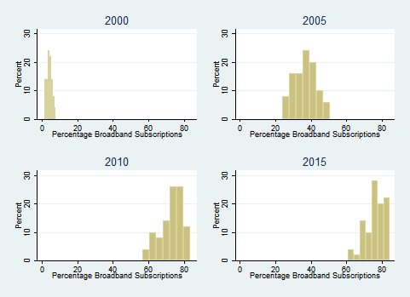

Table 1: Pooled Event History Analysis of State Policy Innovations (2000-2016)*
 | (1) | (2) | (3)
 | 2000-2016 | 1980-1999 | Pooled 1980-2016
Broadband Subscriptions | 1.7326** |  | 0.7365**
 | (0.6056) |  | (0.3600)
Latent Ties | 0.0829*** | 0.1003*** | 0.1315***
 | (0.0220) | (0.0113) | (0.0085)
Geographic Contiguity | 0.1585*** | 0.1878*** | 0.1766***
 | (0.0273) | (0.0178) | (0.0118)
Ideological Distance | -0.0040 | -0.0062 | -0.0081**
 | (0.0052) | (0.0040) | (0.0028)
Population | 0.0538 | 0.1235*** | 0.0994***
 | (0.0356) | (0.0262) | (0.0180)
Public Liberalism | 0.0351 | 0.1516*** | 0.1532***
 | (0.0367) | (0.0346) | (0.0205)
Unified Party Control | 0.0469 | -0.0824** | -0.0143
 | (0.0552) | (0.0353) | (0.0253)
Income Per Capita | -0.1043** | -0.0737* | -0.0677**
 | (0.0424) | (0.0407) | (0.0240)
Legislative Professionalism | -0.0886* | -0.0955*** | -0.1031***
 | (0.0454) | (0.0288) | (0.0213)
Proportion Black | -0.0077 | 0.0088** | 0.0080***
 | (0.0156) | (0.0032) | (0.0024)
Percent High School | 0.0116 | 0.0222*** | 0.0173***
 | (0.0109) | (0.0048) | (0.0035)
Duration | -0.0227 | -0.1954*** | -0.0417**
 | (0.0563) | (0.0305) | (0.0138)
Duration Squared | -0.0027 | 0.0292*** | 0.0016
 | (0.0112) | (0.0045) | (0.0012)
Duration Cubed | 0.0001 | -0.0012*** | -0.0000
 | (0.0006) | (0.0002) | (0.0000)
Constant | -4.7559*** | -3.6510*** | -3.3370***
 | (1.0185) | (0.4269) | (0.3147)
Var(Policy) | 0.8403*** | 1.1815*** | 0.9534***
 | (0.1328) | (0.1219) | (0.0794)
Observations | 28,851 | 95,346 | 170,364
*indicates p<.05, **p<.01 and ***p<.001. Modeling includes fixed effect for year and random effects for policy areas. More policies began diffusing in the 80s and 90s than those that began diffusing the in the 2000s, so the number of observations is larger for the earlier period. Many of the policies from the 2000s are still diffusing, while most from the 80s and 90s are fully diffused. Broadband home subscription first measured by the Census Current Population Survey (CPS) in 2000. Internet use dial-up first measured by Census CPS in 1997.

Figure 2: Predicted Probability of Adopting any given Policy in a Year
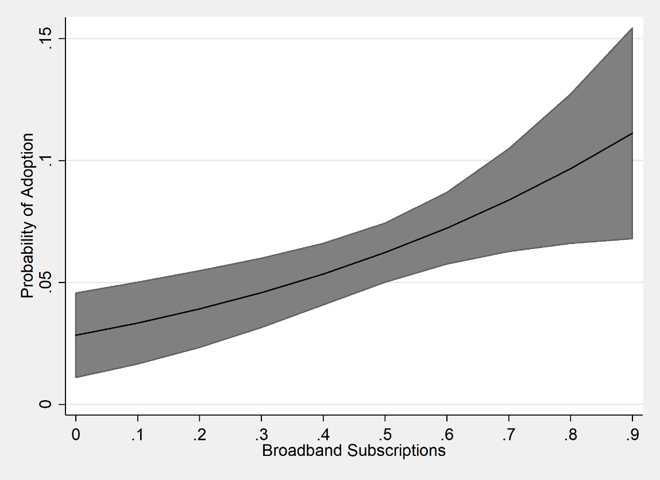

Table 2: Pooled Event History Analysis of State Policy Innovations with Interaction between Geographic Contiguity and Broadband Subscriptions *
 | (1) | (2) |  | (3)
 | 2000-2016 | Pooled 1980-2016 |  | Pooled- Pre 2000 Dummy
Broadband Subscriptions | 1.8702** | 0.7211** |  | 0.6893*
 | (0.6091) | (0.3597) |  | (0.3621)
Geographic Contiguity | 0.3885*** | 0.2199*** |  | 0.2205***
 | (0.0999) | (0.0149) |  | (0.0153)
Broadband # Geographic Contiguity | -0.3478** | -0.1714*** |  | -0.1649***
 | (0.1460) |  | (0.0364) | (0.0367)
Latent Ties | 0.0753*** | 0.1273*** |  | 0.1325***
 | (0.0222) | (0.0085) |  | (0.0087)
Ideological Distance | -0.0033 | -0.0078** |  | -0.0079**
 | (0.0052) | (0.0028) |  | (0.0028)
Population | 0.0545 | 0.0994*** |  | 0.0998***
 | (0.0355) | (0.0180) |  | (0.0182)
Public Liberalism | 0.0291 | 0.1515*** |  | 0.1474***
 | (0.0368) | (0.0205) |  | (0.0208)
Unified Party Control | 0.0482 | -0.0153 |  | -0.0100
 | (0.0552) | (0.0254) |  | (0.0258)
Income Per Capita | -0.1065** | -0.0673** |  | -0.0724**
 | (0.0424) | (0.0240) |  | (0.0245)
Legislative Professionalism | -0.0865* | -0.1019*** |  | -0.0998***
 | (0.0453) | (0.0213) |  | (0.0216)
Proportion Black | -0.0084 | 0.0085*** |  | 0.0093***
 | (0.0156) | (0.0024) |  | (0.0025)
Percent High School | 0.0112 | 0.0182*** |  | 0.0197***
 | (0.0109) | (0.0035) |  | (0.0035)
Duration | -0.0284 | -0.0434** |  | -0.0500***
 | (0.0565) | (0.0138) |  | (0.0141)
Duration Squared | -0.0007 | 0.0020 |  | 0.0026**
 | (0.0112) | (0.0012) |  | (0.0013)
Duration Cubed | 0.0000 | -0.0000 |  | -0.0000
 | (0.0006) | (0.0000) |  | (0.0000)
Before 2000 |  |  |  | -0.1596
 |  |  |  | (0.4728)
Constant | -4.5298*** | -3.3217*** |  | -3.2798***
 | (1.0255) | (0.3148) |  | (0.3543)
Var(Policy) | 0.8495*** | 0.9608*** |  | 0.9449***
 | (0.1341) | (0.0801) |  | (0.0793)
Observations | 28,851 | 170,364 |  | 163,345
*indicates p<.05, ** p<.01, *** p<.001. Modeling includes fixed effect for year and random effects for policy

Figure 3: Marginal Effect of Contiguity at Different Levels of Broadband Subscriptions (Model 1)

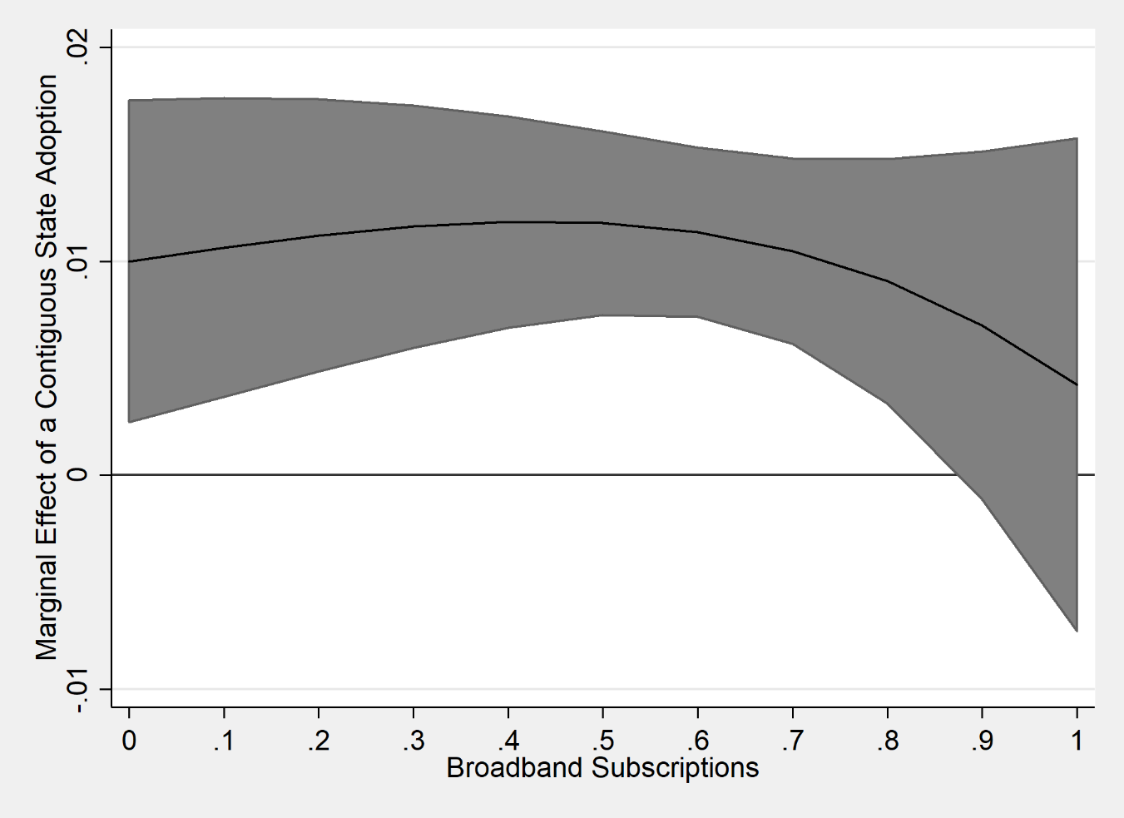

Table 3: Instrumental Variable Regression: Two Stage-Probit with Broadband Treated as Instrumental Variable
 | Stage 1- | Stage 2-
 | Broadband Subscriptions | Policy Adoption
Broadband Subscriptions |  | 4.3008***
 |  | (1.0742)
Geographic Contiguity | -0.0003 | 0.0667***
 | (0.0003) | (0.0147)
Latent Ties | -0.0003 | 0.0318**
 | (0.0003) | (0.0120)
Ideological Distance | 0.0003*** | -0.0048*
 | (0.0001) | (0.0029)
Population | 0.0035*** | 0.0303*
 | (0.0004) | (0.0180)
Public Liberalism | 0.0148*** | -0.0346
 | (0.0003) | (0.0230)
Unified Party Control | 0.0087*** | -0.0034
 | (0.0005) | (0.0299)
Income Per Capita | 0.0335*** | -0.1647***
 | (0.0004) | (0.0414)
Legislative Professionalism | -0.0044*** | -0.0259
 | (0.0004) | (0.0232)
Percent High School | 0.0022*** | -0.0011
 | (0.0001) | (0.0065)
Proportion Black | 0.0010*** | -0.0061
 | (0.0001) | (0.0074)
Duration | -0.0010 | -0.0002
 | (0.0007) | (0.0357)
Duration Squared | 0.0001 | -0.0033
 | (0.0001) | (0.0054)
Duration Cubed | -0.0000 | 0.0001
 | (0.0000) | (0.0003)
Geographic Area | -0.0161***
 | (0.0009)
Flatness | 0.0005***
 | (0.0000)
Average Elevation | 0.0000***
 | (0.0000)
Constant | -0.2116*** | -1.8436**
 | (0.0100) | (0.6050)
Observations |  | 27,689
Wald test of exogeneity: χ² | 11.63 (p<.001)
*indicates p<.05, **p<.01 and ***p<.001. Modeling includes fixed effect for year and random effects for policy.

Following the tradition established in the literature, we define an innovation as a policy that is new to that state, even the policy was developed elsewhere (Eyestone 1972; Walker 1969).
We note these are not the only dynamics studied by scholars, as there is a robust debate on how to best develop and operationalize state policy diffusion mechanisms (see LaCombe and Boehmke 2020 for comprehensive reviews).
See figure 1 for the distribution of broadband subscription rates across the states at different time points.
See supplemental material of summary statistics and graph on the number of observations and adoptions per year.
See supplemental material for example of question wording for broadband.
As a robustness check we estimated models with fixed effects for policy and our findings remain the same. Broadband remains a powerful predictor of innovation and moderates the effect of contiguity in this specification.
We also estimated parallel models with Bowen and Greene’s (2014) measures for legislative professionalism. The model conclusions are unchanged.
We tried controlling for the size of the Latino population in a county and the results were unchanged.
We estimated models with and without year fixed effects and the cubic polynomial and found broadband to have the same relationship with adoption in both significance and direction across models.
While single policy studies have often found legislative professionalism to positively predict innovation (Berry 1994; Shipan and Volden 2006) multiple policy analyses (Mallinson 2019; Bricker and LaCombe 2020) find legislative professionalism is negatively associated with innovation.
A potential concern is that broadband’s positive effect is due to new types of policies being adopted in the last 20 years or different policy characteristic. Perhaps the policies being adopted since 2000 are more partisan than earlier eras, leading to changing policy characteristics, not broadband, leading to increased innovation. In addition to including a measure of the ideological distance between states, we also subsampled our analysis to only include policies that we clearly non-ideological to test of partisan polarization is driving our results rather than broadband. We estimate the same models on only policies from the Uniform Law Commission, an organization that produces non-partisan model legislation. Our results hold for in terms of direction and significance for all our hypotheses. These robustness checks increase our confidence that broadband is leading to higher rates of policy innovation.
Source: American Community Survey and Current Population Survey
Predicted probabilities are generated from the fixed component of the model and reflect the averaged random effects. Fixed effects are included for year

